`

Welcome To
Trinity Lutheran Church
Lutheran Church—Missouri Synod
A Stephen Ministry Congregation

1354 South Otsego Avenue
Gaylord, Michigan 49735
Church Phone: (989) 732-4816

Church Email: secretary@trinitygaylord.com
www.trinitygaylord.com

Office Hours: Monday through Friday 9am – 1pm

OUR PURPOSE
…is to LOVE GOD, LOVE OTHERS, AND SERVE THE WORLD by worshiping the Lord Jesus, bringing our members into Christ-like maturity, and equipping them through Word and Sacrament for their mission and ministry. We go heart to heart into the world with Jesus, sharing His love, caring for one another, praying, and bringing the lost into a relationship with Christ, by the working of the Holy Spirit.

February 19, 2023
Transfiguration of Our Lord
Preacher: Rev. Ken Bernthal

ABOUT OUR WORSHIP
We welcome all who gather here today! We are blessed to celebrate together the mercy, grace, and love we have from God through the death and resurrection of our Lord Jesus Christ.

Children: Families with children are very welcome here. Having children in church is important so they can begin to learn about their faith in Jesus, and it’s good for the whole congregation to see. Please feel comfortable keeping “squirmy” kids in the service. This is where they belong, too!

Pew Cards: Guests and Members, please fill out the Guest/Member card located on the back of the pew in front of you and pass it to the end of the aisle. If you forget you can put it in the offering plate on your way out.

If standing is difficult: Please feel free to remain seated during any portion of the service. Please let an Elder or Usher know if you need communion in your pew seat.

About our celebration of Holy Communion: We celebrate the Lord’s Supper in the confession and glad confidence that, as he says, our Lord gives into our mouths not only bread and wine but his very body and blood to eat and to drink for the forgiveness of sins and to strengthen our union with him and with one another. Our Lord invites to his table those who trust his words, repent of all sin, and set aside any refusal to forgive and love as he forgives and loves us, that they may show forth his death until he comes.

Because those who eat and drink our Lord’s body and blood contrary to that which is stated above do so to their great harm, and also because Holy Communion is a confession of the faith which is confessed at this altar. Anyone who is not yet instructed, in doubt, or who hold a confession differing from that of the Lutheran Church—Missouri Synod, and yet desire to receive the sacrament, are asked first to speak with Pastor. Those not communing are still invited to come forward for a blessing from Pastor, and you may indicate this by crossing your arms over your chest.
TTTTTT
GREETING

P Peace be with you.
C And also with you.

T ORDER OF SERVICE T
(The liturgy is from Divine Service Setting four LSB pg. 203ff)

OPENING HYMN
’Tis Good, Lord, to Be Here LSB 414
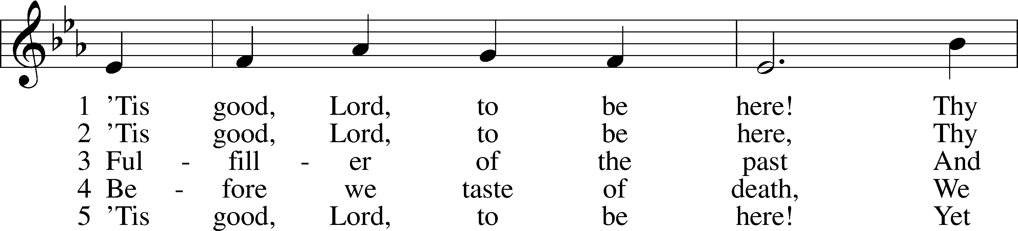
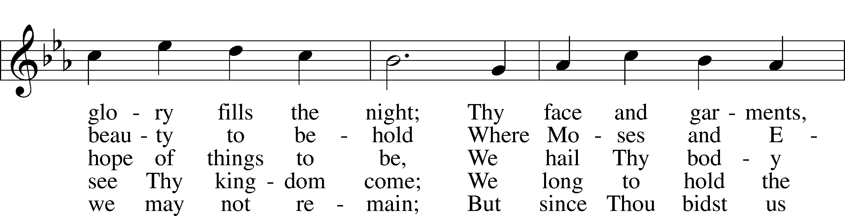
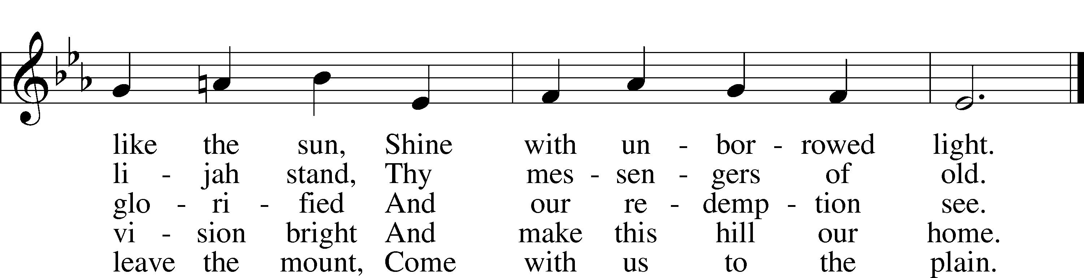

Please stand as able

CONFESSION and ABSOLUTION
The sign of the cross may be made by all in remembrance of their Baptism.

P In the name of the Father and of the T Son and of the Holy Spirit.
C Amen.
P Our help is in the name of the Lord,
C who made heaven and earth.
P If You, O Lord, kept a record of sins, O Lord, who could stand?
C But with You there is forgiveness; therefore You are feared.

P Since we are gathered to hear God’s Word, call upon Him in prayer and praise, and receive the body and blood of our Lord Jesus Christ in the fellowship of this altar, let us first consider our unworthiness and confess before God and one another that we have sinned in thought, word, and deed, and that we cannot free ourselves from our sinful condition. Together as His people let us take refuge in the infinite mercy of God, our heavenly Father, seeking His grace for the sake of Christ, and saying: God, be merciful to me, a sinner.
C Almighty God, have mercy upon us, forgive us our sins, and lead us to everlasting life. Amen.

P Almighty God, merciful Father, in Holy Baptism You declared us to be Your children and gathered us into Your one, holy Church, in which You daily and richly forgive us our sins and grant us new life through Your Spirit. Be in our midst, enliven our faith, and graciously receive our prayer and praise; through Your Son, Jesus Christ, our Lord.
C Amen.
T SERVICE OF THE WORD T
INTRIOT Psalm 99:1–5; antiphon: v. 9
P Exalt the Lord our God, and worship at his holy mountain;
for the Lord our God is holy!
C The Lord reigns; let the peoples tremble!
He sits enthroned upon the cherubim; let the earth quake!
P The Lord is great in Zion;
he is exalted over all the peoples.
C Let them praise your great and awesome name!
Holy is he!
P The King in his might loves justice.
You have established equity; you have executed justice and righteousness in
Jacob
C Exalt the Lord our God; worship at his footstool!
Holy is he!
A Glory be to the Father and to the Son
and to the Holy Spirit;
as it was in the beginning,
is now, and will be forever. Amen.
P Exalt the Lord our God, and worship at his holy mountain;
for the Lord our God is holy!
KYRIE LSB 204
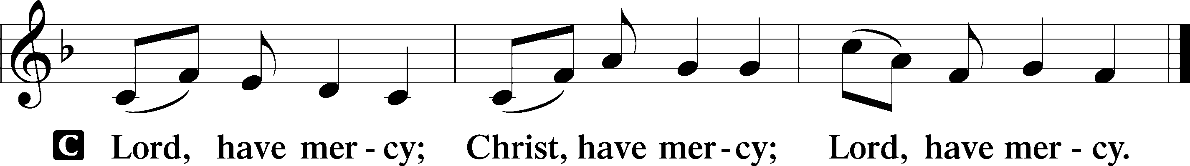

HYMN OF PRAISE
GLORIA IN EXCELSIS LSB 204
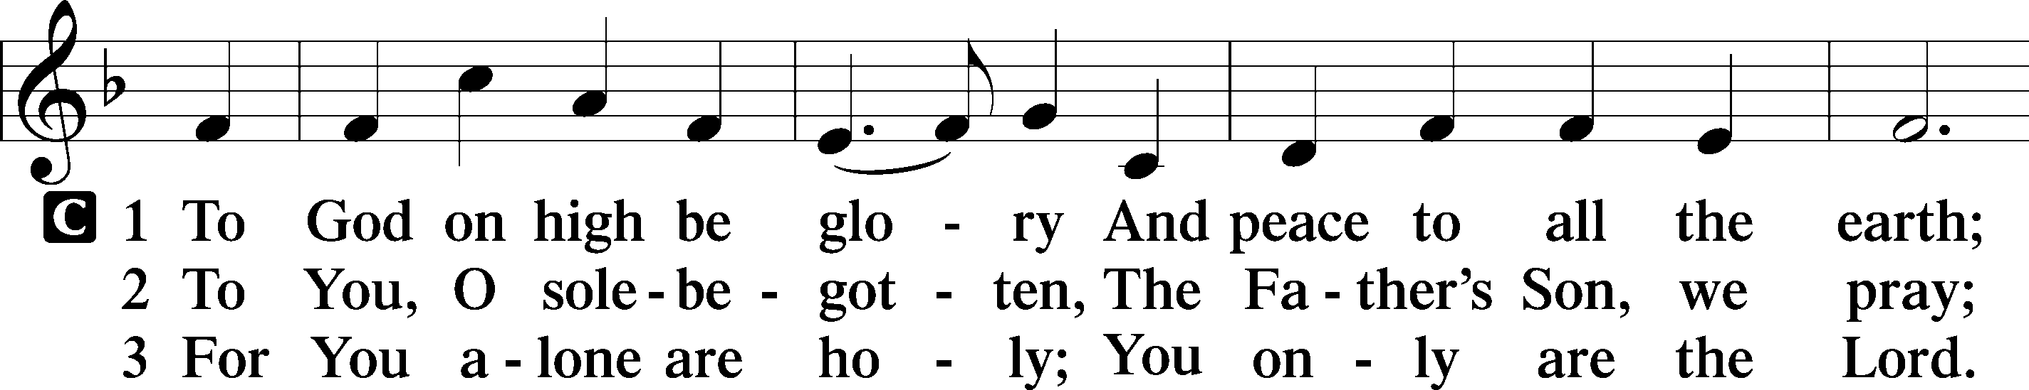
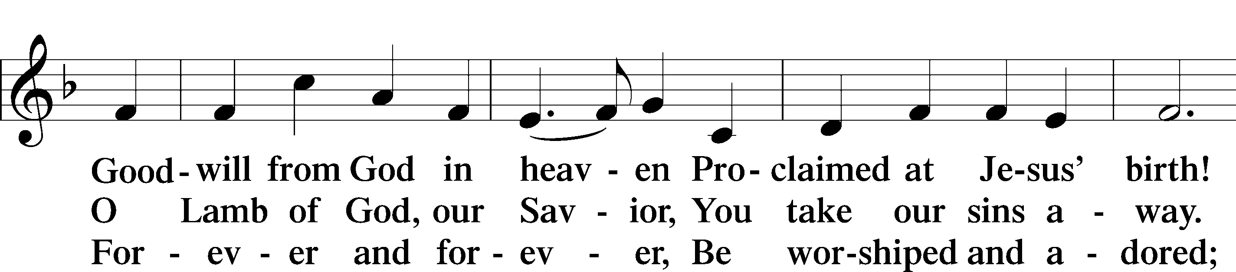
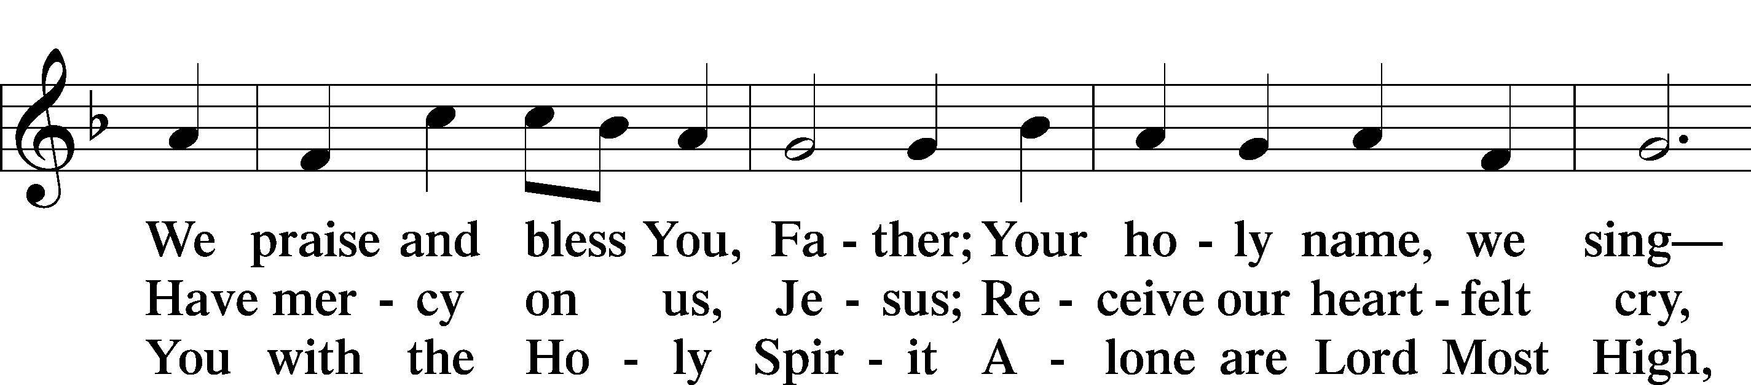
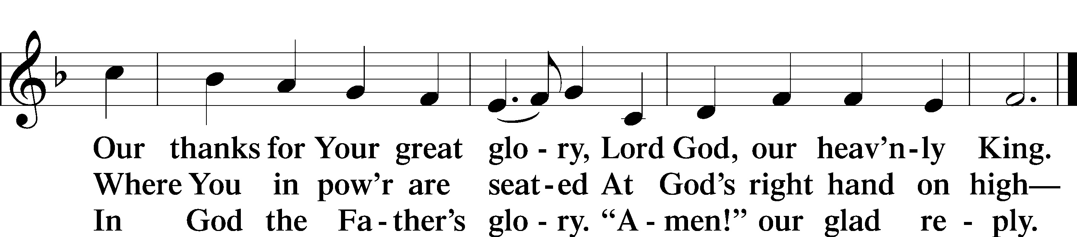

SALUTATION AND COLLECT OF THE DAY
P The Lord be with you.
C And also with you.
.P Let us pray.
O God, in the glorious transfiguration of Your beloved Son You confirmed the mysteries of the faith by the testimony of Moses and Elijah. In the voice that came from the bright cloud You wonderfully foreshowed our adoption by grace. Mercifully make us co-heirs with the King in His glory and bring us to the fullness of our inheritance in heaven; through the same Jesus Christ, our Lord, who lives and reigns with You and the Holy Spirit, one God, now and forever.
C Amen.

Please be seated
OLD TESTAMENT READING Exodus 24:8–18

⁸And Moses took the blood and threw it on the people and said, “Behold the blood of the covenant that the Lord has made with you in accordance with all these words.”
⁹Then Moses and Aaron, Nadab, and Abihu, and seventy of the elders of Israel went up, ¹⁰and they saw the God of Israel. There was under his feet as it were a pavement of sapphire stone, like the very heaven for clearness. ¹¹And he did not lay his hand on the chief men of the people of Israel; they beheld God, and ate and drank.

¹²The Lord said to Moses, “Come up to me on the mountain and wait there, that I may give you the tablets of stone, with the law and the commandment, which I have written for their instruction.” ¹³So Moses rose with his assistant Joshua, and Moses went up into the mountain of God. ¹⁴And he said to the elders, “Wait here for us until we return to you. And behold, Aaron and Hur are with you. Whoever has a dispute, let him go to them.”
¹⁵Then Moses went up on the mountain, and the cloud covered the mountain. ¹⁶The glory of the Lord dwelt on Mount Sinai, and the cloud covered it six days. And on the seventh day he called to Moses out of the midst of the cloud. ¹⁷Now the appearance of the glory of the Lord was like a devouring fire on the top of the mountain in the sight of the people of Israel. ¹⁸Moses entered the cloud and went up on the mountain. And Moses was on the mountain forty days and forty nights.

P This is the Word of the Lord.
C Thanks be to God.

EPISTLE READING 2 Peter 1:16–21
¹⁶For we did not follow cleverly devised myths when we made known to you the power and coming of our Lord Jesus Christ, but we were eyewitnesses of his majesty. ¹⁷For when he received honor and glory from God the Father, and the voice was borne to him by the Majestic Glory, “This is my beloved Son, with whom I am well pleased,” ¹⁸we ourselves heard this very voice borne from heaven, for we were with him on the holy mountain. ¹⁹And we have something more sure, the prophetic word, to which you will do well to pay attention as to a lamp shining in a dark place, until the day dawns and the morning star rises in your hearts, ²⁰knowing this first of all, that no prophecy of Scripture comes from someone’s own interpretation. ²¹For no prophecy was ever produced by the will of man, but men spoke from God as they were carried along by the Holy Spirit.

P This is the Word of the Lord.
C Thanks be to God.

Please stand as able

ALLELUIA AND VERSE
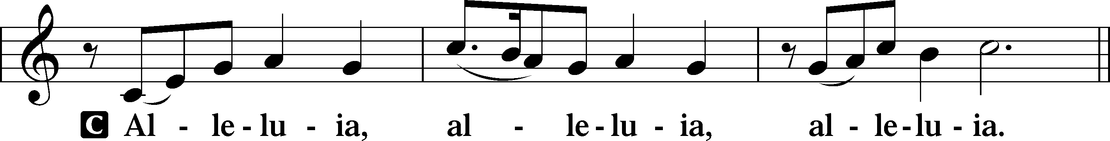
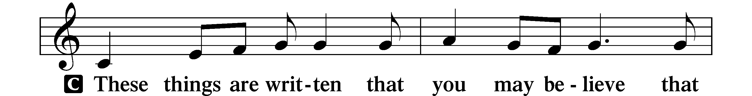
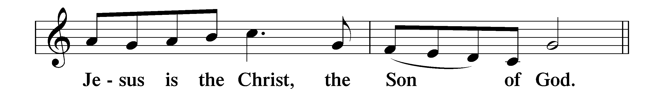
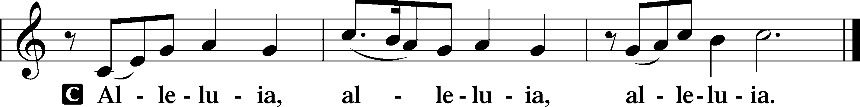

HOLY GOSPEL Matthew 17:1–9
P The Holy Gospel according to St. Matthew, the seventeenth chapter.
C Glory to You, O Lord.

¹After six days Jesus took with him Peter and James, and John his brother, and led them up a high mountain by themselves. ²And he was transfigured before them, and his face shone like the sun, and his clothes became white as light. ³And behold, there appeared to them Moses and Elijah, talking with him. ⁴And Peter said to Jesus, “Lord, it is good that we are here. If you wish, I will make three tents here, one for you and one for Moses and one for Elijah.” ⁵He was still speaking when, behold, a bright cloud overshadowed them, and a voice from the cloud said, “This is my beloved Son, with whom I am well pleased; listen to him.” ⁶When the disciples heard this, they fell on their faces and were terrified. ⁷But Jesus came and touched them, saying, “Rise, and have no fear.” ⁸And when they lifted up their eyes, they saw no one but Jesus only.
⁹And as they were coming down the mountain, Jesus commanded them, “Tell no one the vision, until the Son of Man is raised from the dead.”

P This is the Gospel of the Lord.
C Praise to You, O Christ.
NICENE CREED
C I believe in one God,
the Father Almighty,
maker of heaven and earth
and of all things visible and invisible.
And in one Lord Jesus Christ,
the only-begotten Son of God,
begotten of His Father before all worlds
God of God, Light of Light,
very God of very God,
begotten, not made,
being of one substance with the Father,
by whom all things were made;
who for us men and for our salvation came down from heaven
and was incarnate by the Holy Spirit of the virgin Mary
and was made man;
and was crucified also for us under Pontius Pilate.
He suffered and was buried.
And the third day He rose again according to the Scriptures
and ascended into heaven
and sits at the right hand of the Father.
And He will come again with glory to judge both the living and the dead,
whose kingdom will have no end.
And I believe in the Holy Spirit,
the Lord and giver of life,
who proceeds from the Father and the Son,
who with the Father and the Son together is worshiped and glorified,
who spoke by the prophets.
And I believe in one holy Christian and apostolic Church,
I acknowledge one Baptism for the remission of sins,
and I look for the resurrection of the dead
and the life T of the world to come. Amen.

Please be seated

ALL GOD’S CHILDREN – TALK

SERMON HYMN

Take My Life and Let it Be LSB 783
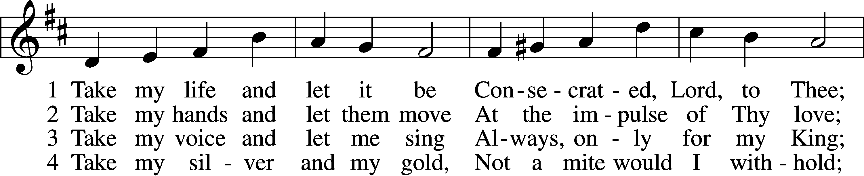
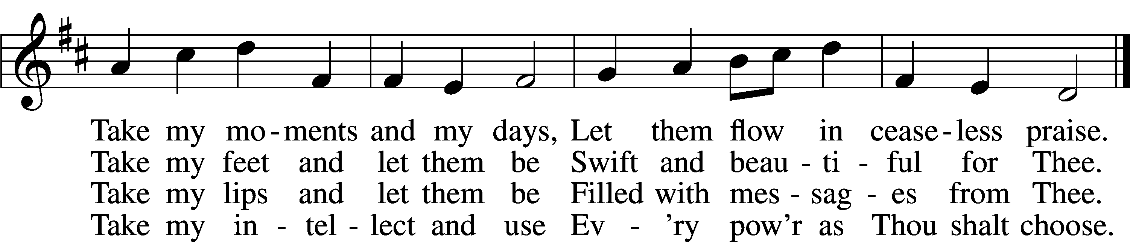

5 Take my will and make it Thine,
It shall be no longer mine;
Take my heart, it is Thine own,
It shall be Thy royal throne.

6 Take my love, my Lord, I pour
At Thy feet its treasure store;
Take myself, and I will be
Ever, only, all for Thee.

SERMON
Please stand as able
PRAYER of the CHURCH
After each Segment:
P Lord, in Your Mercy,
C Hear our Prayer.
Final Segment:
P Hear us as we pray in His name and as He has taught us:

LORD’S PRAYER
Our Father who art in heaven,
Hallowed be thy name,
Thy kingdom come,
Thy will be done
On earth as it is in heaven.
Give us this day our daily bread;
And forgive us our trespasses
As we forgive those
Who trespass against us;
And lead us not into temptation,
But deliver us from evil.
For thine is the kingdom
And the power and the glory
Forever and ever. Amen

PREFACE LSB 208

P The Lord be with you.
C And also with you.

P Lift up your hearts.
C We lift them to the Lord.

P Let us give thanks to the Lord our God.
C It is right to give Him thanks and praise.

P It is truly good, right, and salutary that we should at all times and in all places give thanks to You, O Lord, holy Father, almighty and everlasting God, for the countless blessings You so freely bestow on us and all creation. Above all, we give thanks for Your boundless love shown to us when You sent Your only-begotten Son, Jesus Christ, into our flesh and laid on Him our sin, giving Him into death that we might not die eternally. Because He is now risen from the dead and lives and reigns to all eternity, all who believe in Him will overcome sin and death and will rise again to new life. Therefore with angels and archangels and with all the company of heaven we laud and magnify Your glorious name, evermore praising You and singing:

SANCTUS LSB 208
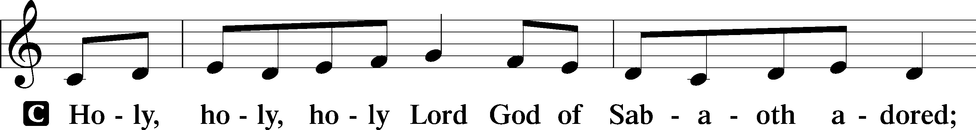
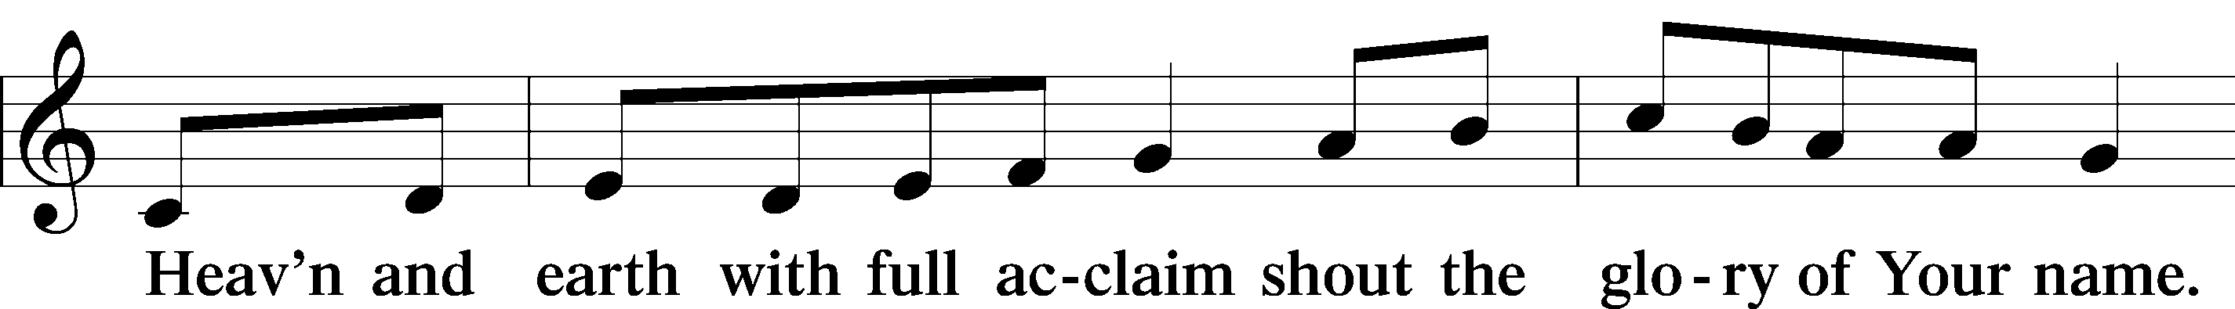
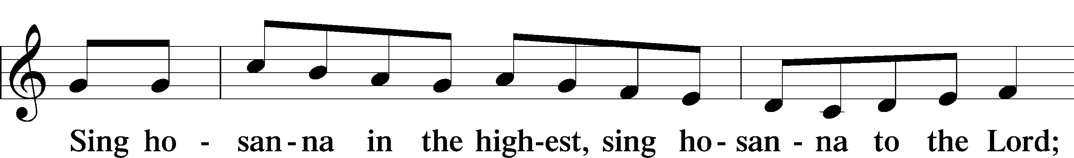
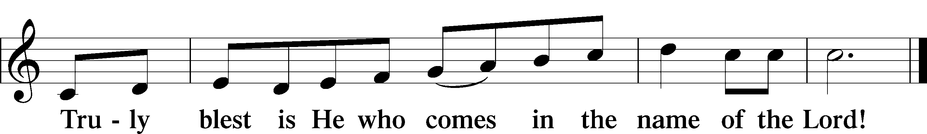

PRAYER OF THANKSGIVING
P Blessed are You, O Lord our God, king of all creation, for You have had mercy on us and given Your only-begotten Son that whoever believes in Him should not perish but have eternal life.

At Your command, Abraham prepared to offer his son Isaac as a sacrifice on the mountain; yet, in mercy You provided a ram as a substitute. We give You thanks that on Calvary You spared not Your only Son but sent Him to offer His life as a ransom for many.

As we eat and drink His body and blood, grant us, like Abraham our father, to trust in Your promise now fulfilled in Christ, the Lamb of God, who takes away the sin of the world.

THE WORDS of our LORD
P Our Lord Jesus Christ, on the night when He was betrayed, took bread, and when He had given thanks, He broke it and gave it to the disciples and said: “Take, eat; this is My T body, which is given for you. This do in remembrance of Me.”

In the same way also He took the cup after supper, and when He had given thanks, He gave it to them, saying: “Drink of it, all of you; this cup is the new testament in My T blood, which is shed for you for the forgiveness of sins. This do, as often as you drink it, in remembrance of Me.”

PAX DOMINI
P The peace of the Lord be with you always.
C Amen.

AGNUS DEI LSB 210
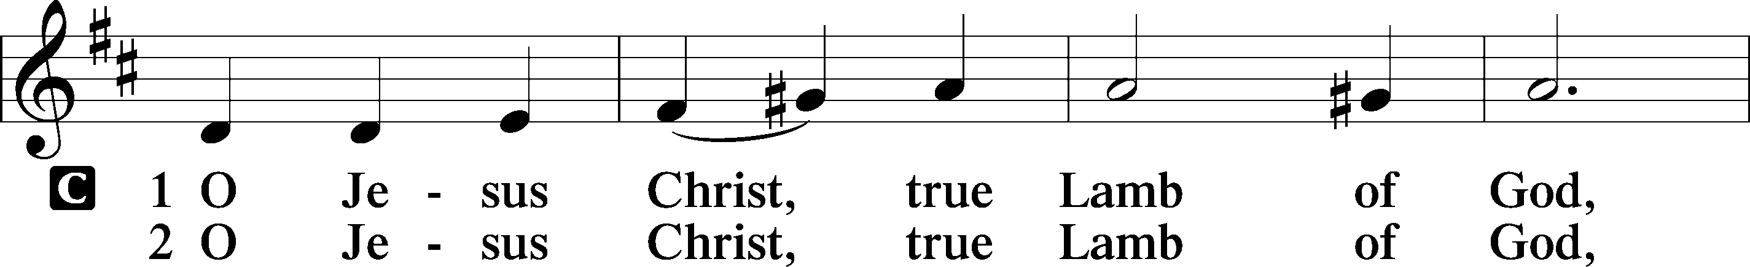
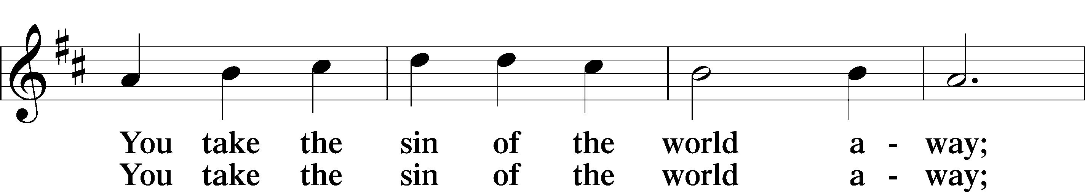
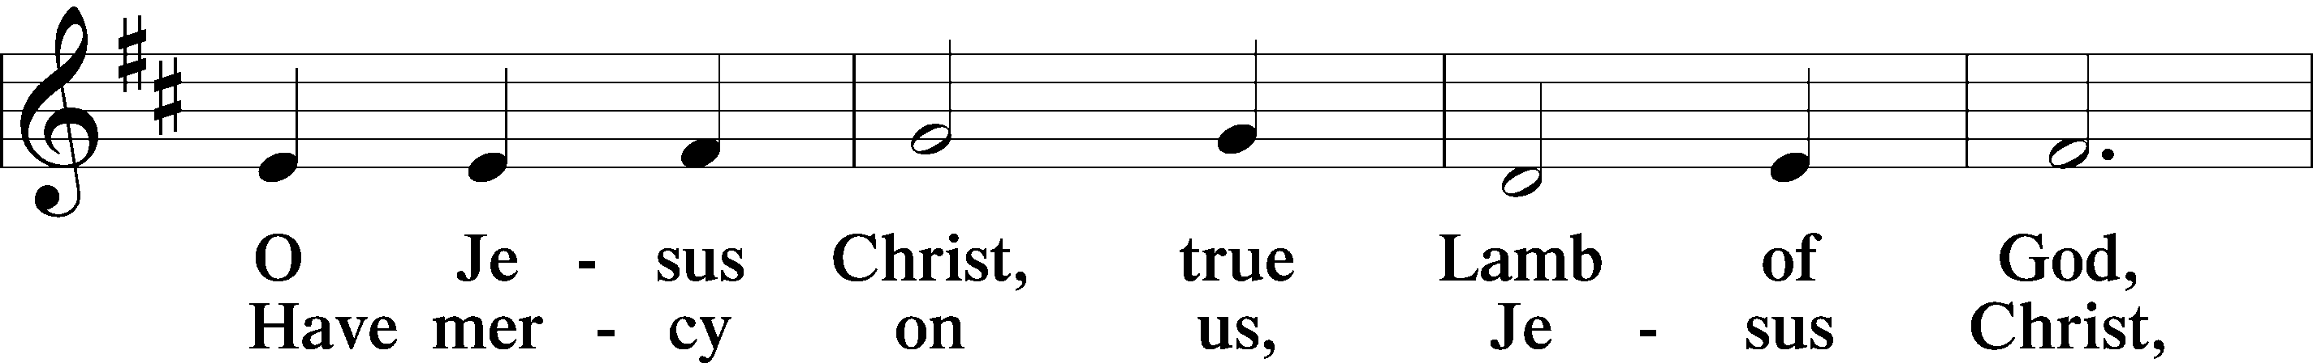
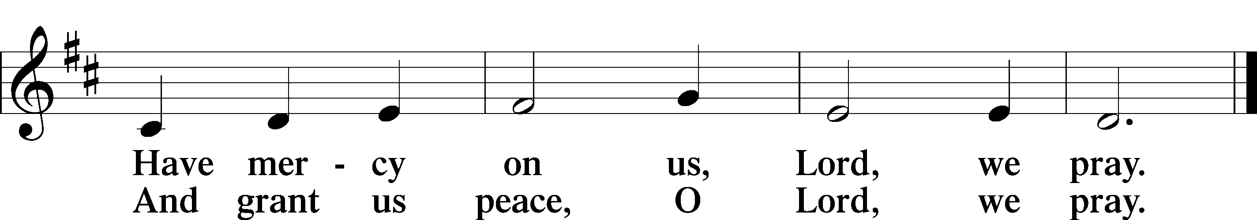

Please be Seated

The pastor and those who assist him receive the body and blood of Christ first, then Communion will be served at the rail. Ushers will help direct you forward via the center aisle; please return to your seats via the side aisles. Gluten-free bread is available for those who need it, as is non-alcoholic grape juice. Simply request either when you come forward to receive Communion.
DISTRIBUTION HYMN
At the Lamb’s High Feast We Sing LSB 633
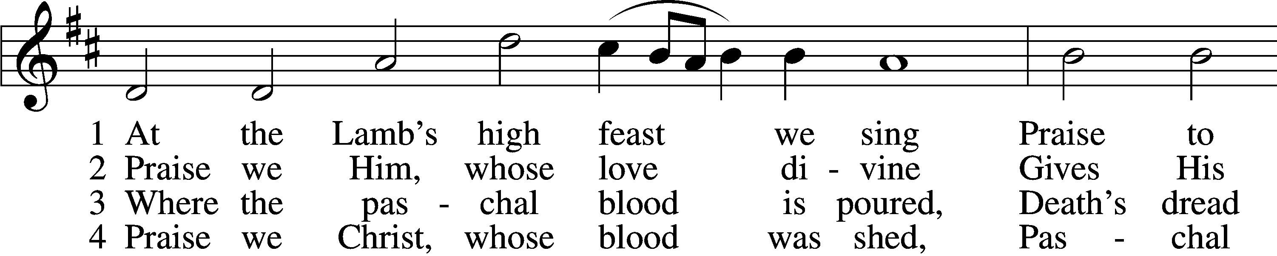
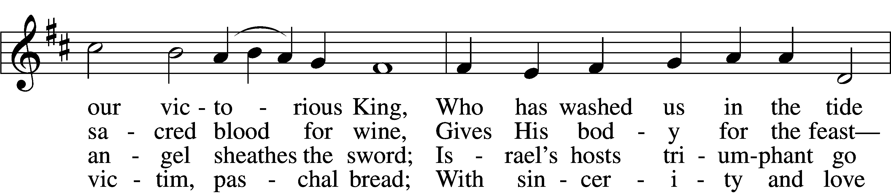
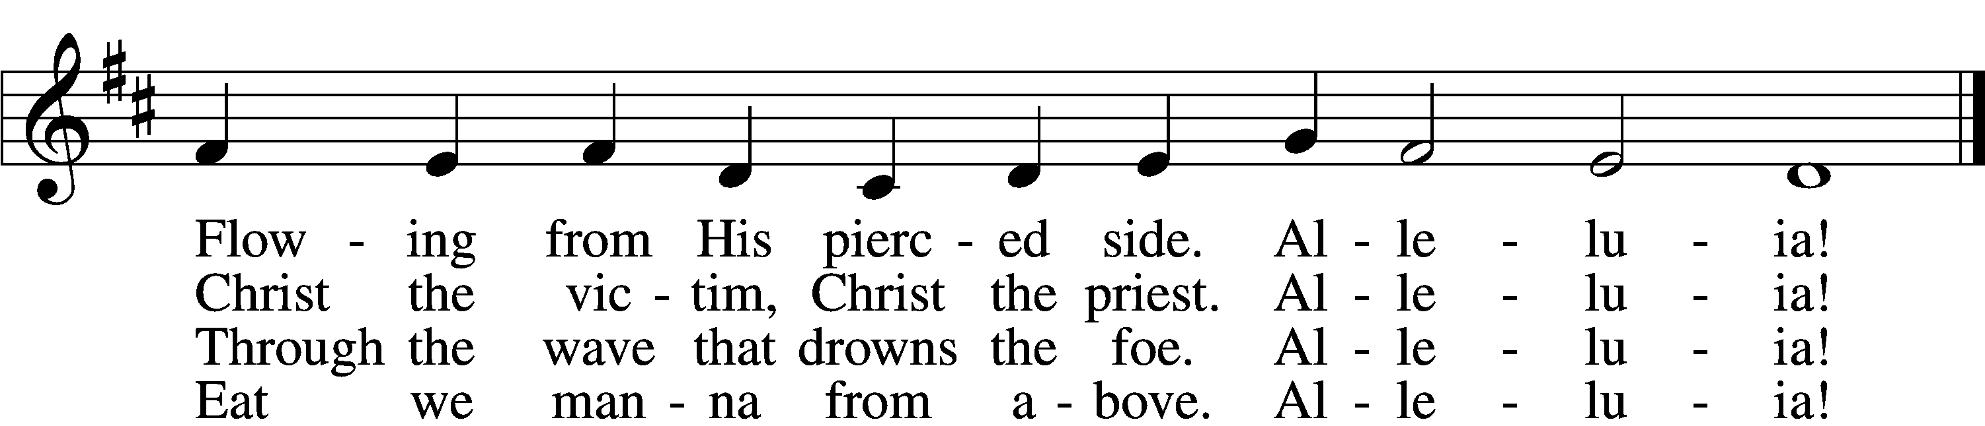

5 Mighty Victim from the sky,
Hell’s fierce pow’rs beneath You lie;
You have conquered in the fight,
You have brought us life and light.
Alleluia!
6 Now no more can death appall,
Now no more the grave enthrall
You have opened paradise
And Your saints in You shall rise.
Alleluia!
7 Easter triumph, Easter joy!
This alone can sin destroy;
From sin’s pow’r, Lord, set us free,
Newborn souls in You to be.
Alleluia!
8 Father, who the crown shall give,
Savior, by whose death we live,
Spirit, guide through all our days:
Three in One, Your name we praise.
Alleluia

Please stand as able
NUNC DIMITTIS LSB 211
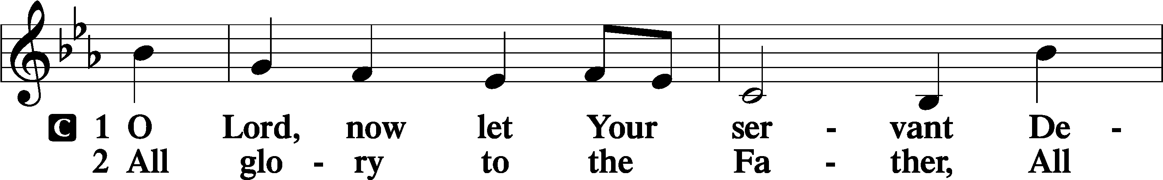
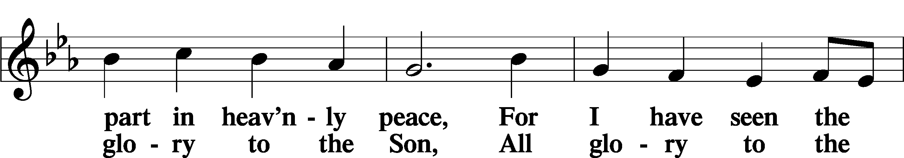
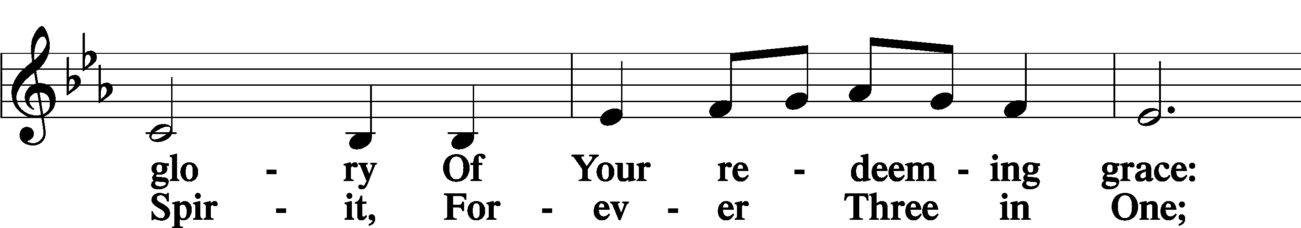
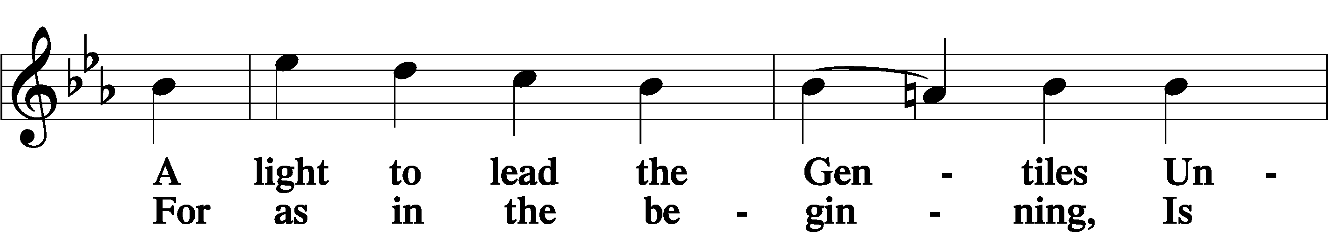
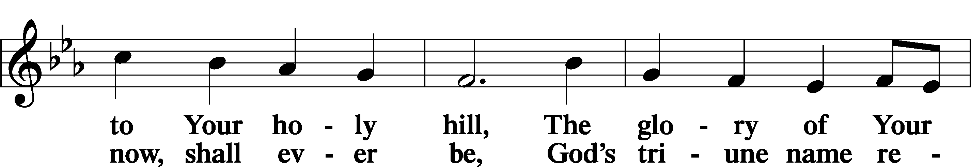
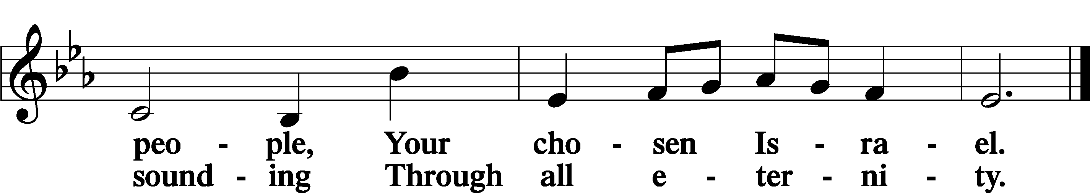

POST COMMUNION COLLECT
P Let us pray.
We give thanks to You, almighty God, that You have refreshed us through this salutary gift, and we implore You that of Your mercy You would strengthen us through the same in faith toward You and in fervent love toward one another; through Jesus Christ, Your Son, our Lord, who lives and reigns with You and the Holy Spirit, one God, now and forever.
C Amen

BENEDICAMUS LSB 212
P Let us bless the Lord.
C Thanks be to God.
BENEDICTION
P The Lord bless you and keep you.
The Lord make His face shine on you and be gracious to you.
The Lord look upon you with favor and T give you peace.
C Amen.

Please be seated

CLOSING HYMN
Guide Me, O Thou Great Redeemer LSB 918
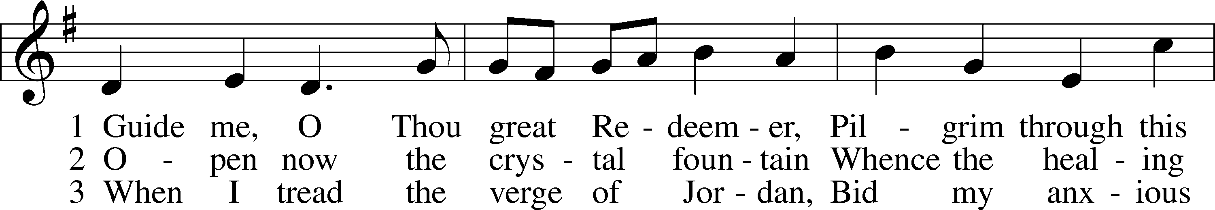
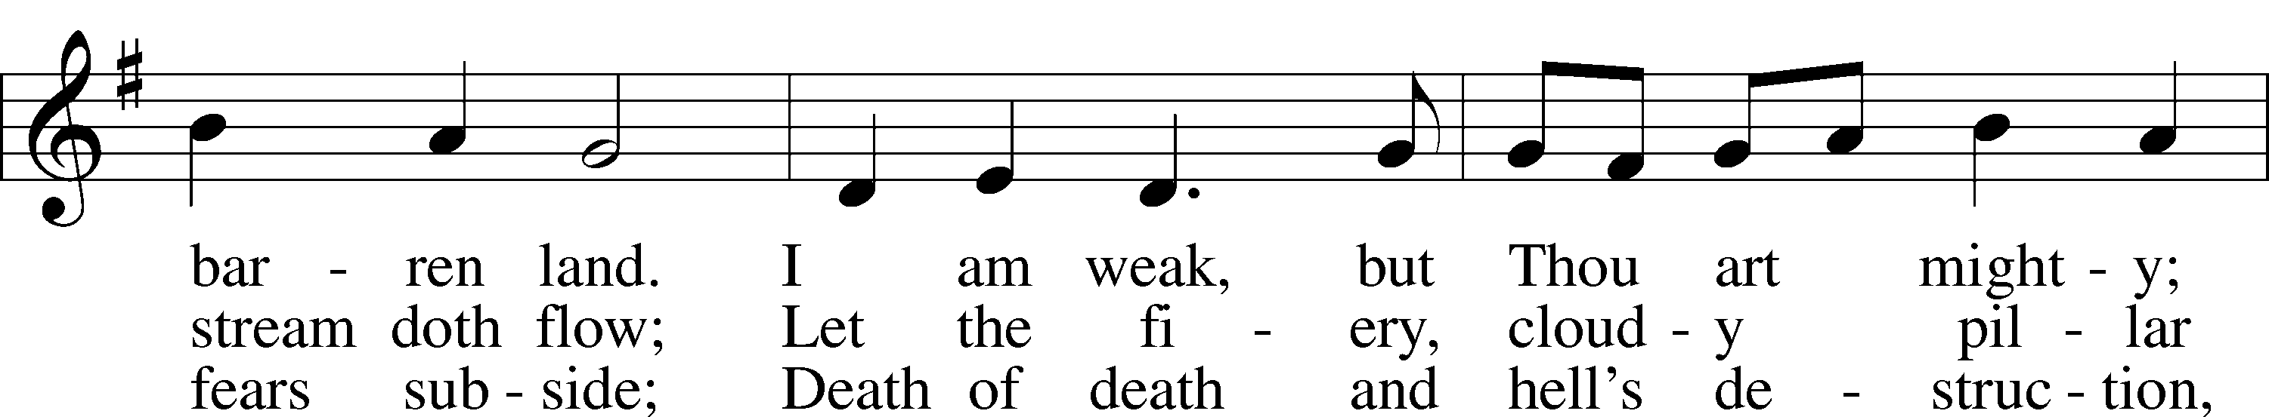
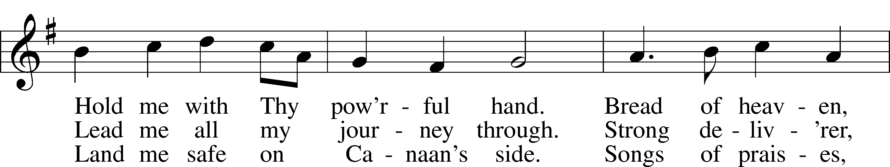
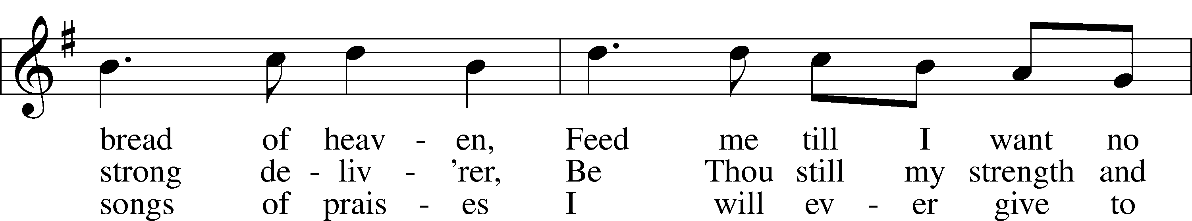
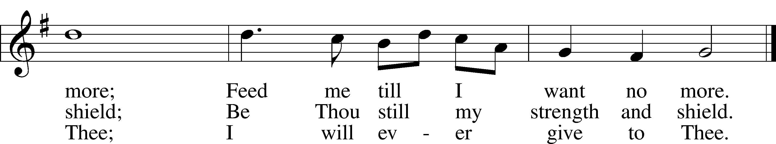
BIBLE AND ME PRESENTATION CEREMONY

ANNOUNCEMENTS and SENDING WORDS
P We go to live for Jesus!
C We go to share His love!

Acknowledgments
Unless otherwise indicated, Scripture quotations are from the ESV® Bible (The Holy Bible, English Standard Version®), copyright 2001 by Crossway, a publishing ministry of Good News Publishers. Used by permission. All rights reserved. Created by Lutheran Service Builder. Music reproduced in this service is used with permission through: CCLI License No.1776588 and CPH – LSB Service Builder.

SERVING in GODS HOUSE TODAY
Pastor: Rev. Ken Bernthal
Elder: Tom Raithel
Ushers: Linda West, Roxy Mohr
Greeters: Raithels
Coffee: Raithels
Counters: Kathy Erat, Kayla Albrecht
Altar Care: Nancy Ely
Children’s Talk: Nancy Ely
Virtual Organist: Bob Erat
Children’s Sunday School: Nancy Ely, Jean Beach, Sharon Techel
Confirmation Class: Pastor Paul Schneider in Library
Sunday Morning Bible Study: Dr. Tom Beach

PRAYERS

Please contact the office with updates to the prayer list. People will remain on the prayer list for 4 weeks before being removed. If they need to remain on the list, please keep Elaine informed and of any updates. This will help us to have a more accurate list. Thanks for your cooperation.
Those who continue to grieve the passing of loved ones:.Family of Judy Murdock.
Those with upcoming surgery and medical procedures:
Those recovering from surgery and medical procedures: Tanner Beyers, Marge Kunisch, Jean Seibel, and Bill Stiles.
Those with health concerns: Tiffany Amsdill, Ruth Bennett (Sharron Kato’s Sister), Jackie Bliss, Hope Buchinger, Betsy Cook, George Drallos, Steve Foley, Elaine Foley, Shirley Hildebrand, Paul Kietzman, Jennifer Martin, Marina Murdock, Gladys Pickering, Eleanor Raether, Beth Smith, Tina Spencer, Judi Stutzman, Joann Whitney, and Lyle Yingling a friend of Larry Whitney daughter.
Those diagnosed with cancer: Sue Cavanagh, Leah Eicher, Rachel Frisch, Leslie Martin, Brian Morgan, Hope Osantowski. Leanne, Sheryl Marsh (Shirley Hildebrand daughter), and Larry Schiewe.
Those under Hospice Home Care: Ken Williamson, Jim (Joann Whitney brother-in law).

MESSAGES
MEMBER & GUEST CARDS: If you have not filled out a member/guest card, please take the time to fill one out and place it in the plate behind the back pews in our sanctuary.
WEDNESDAY MORNING BIBLE STUDY, 10:00am in the fellowship hall with Pastor Ken Bernthal.
GREETING CARDS If you are in need of some greeting cards, we carry an array of them in the cabinet in the library. The Valentines and Easter cards have been put out. The cost of the cards is posted on the cabinet. The money collected from the cards goes to LWML to help support Missions.
CANCER and FRIENDS SUPPORT GROUP: Will be meeting February 28th
Please remember Cancer & Friends Support Group is not just for people going through treatment, or survivors, we are also here for caregiver, spouse, children, and friends. There are times when we can all use someone to talk to during those difficult times. If there is any subject you would like to discuss with me you call or text or at 989-350-4391. Hope you will join us.
KUT-UPS will be meeting Monday February 20th, 10am in the fellowship hall.
NLPRC BABY BOTTLE CAMPAIGN: We are participating in New Life Pregnancy Resource Center’s Baby Bottle Campaign, a fundraiser for their cause in supporting life. We handed out baby bottles to fill will your donations a couple weeks ago, but we ran out of bottles to distribute. We have acquired more, so if you would like one, they are available today in our narthex as you leave. We ask that you return them by late February.
ASH WEDNESDAY: Mark your calendar for February 22nd at 7pm, after the service the Ladies Guild will be serving Pie and Coffee in the fellowship hall, we would like to invite everyone at the service to come and join us for coffee and pie. If anyone is interested we can always use more pies (that is if you enjoy baking).
LWML meeting will be held Tuesday, February 21 at 3 PM and will end with a soup supper at approximately 5 PM. If you are working or can’t otherwise attend at 3, please come at 5 to enjoy the soup and fellowship. All ladies are welcome. Our topic for this month will be ministry to prisons and first responders.
USE OF FELLOWSHIP HALL; Do you need a place to hold a function? Baby Shower, Wedding Shower, Birthday Party? The church fellowship hall is open for members and non-members to use. Fill out the Use Form I the church office and .we can help you secure the church for your event. This has to be cleared through the proper channels for the use of the church. So please fill out a month in advance for earlier if possible. There is a TV in the fellowship hall that will allow you to access different applications you can show a slide show using training video and much more. If you have any questions feel free to call the church or send me an email to tina.vantil@gmail.com
TRINITY’S FOOD TRUCK: These are the tentative dates for Trinity’s Food Giveaway events in our parking lot…all on Fridays. Let me know if you see any conflicts. These dates are not yet locked in, but please put them on your calendars, and I’ll let you know if they change from what are here listed.
- June 16
- July 7
- August 18
- Sept 8
Kathy

LWML meeting will be Tuesday, February 21 at 3 PM and will end with a soup supper at approximately 5 PM. Our mission project for this month is to provide 40 Bibles to the inmates at the Otsego County Jail. We will be marking them to outline the plan of salvation. We need all ladies to join us to help in this important project. We'll teach you how to do the marking. If you are working or can't otherwise attend at 3, please come at 5 to enjoy soup and fellowship.
FOOD PANTRY: Please remember next week is the fourth Sunday of the month
and we are collecting Non-Perishable food items for the Food Pantry Basket located in the narthex.
NOISY OFFERING: Next Sunday the fourth Sunday of the month we will be doing the noisy offering. (We invite you to put your pocket change in the buckets located at the back of the church where the membership cards are located to support our local Food Pantry.)

BIRTHDAYS: ANNIVERSARIES:
2/22 George Bahlam NONE

SERVING in GODS HOUSE for ASH WEDNESDAY
Pastor: Ken Bernthal:
Elder: Tom Raithel
Coffee & Pie: Ladies Guild
Virtual Organ: Judy Stutzman

READINGS FOR ASH WEDNESDAY
Old Testament: Joel 2:12-19
Epistle Reading: 2 Corithians 5:20b-6:10
Holy Gospel: John: 11:45-53

SERVING in GODS HOUSE NEXT WEEK

Pastor: Rev. Ken Bernthal
Elder: Glenn Smith
Ushers: Mike Goodrich, Ron Tesolin
Greeters: Beyers Family
Coffee: Karen Schneider
Counters: Sharon Kwapis, Janet Arner
Altar Care: Karen Schneider
Children’s Talk: Nancy Ely
Piano/Organ: Beaches
Children’s Sunday School: Nancy Ely, Jean Beach, Sharon Techel
Confirmation Class: Pastor Paul Schneider in the Library
Sunday Morning Bible Study with Dr. Tom Beach

READINGS FOR NEXT WEEK
First Reading: Genesis 3:1-21
Second Reading: Romans 5:12-19
Gospel: Matthew: 26:36-46

THIS WEEK AT TRINITY

February 19 Sunday
9:00 am Worship Service - Holy Communion
10:00 am Fellowship & Coffee Hour
10:30 am Sunday Morning Bible Study W/ Dr. Tom Beach
10:30 am Children’s Sunday School.
10:30 am Confirmation Class Pastor Paul Schneider (in Library)
February 20 Monday
7:00 pm Choir
February 21 Tuesday
3 pm LWML Dinner meeting
February 22 Wednesday
10:00 am Wednesday Morning Bible Study W/ Pastor Ken Bernthal
7:00 pm Ash Wednesday Service
After the Service Fellowship- pie and coffee
February 23 Thursday
7:00 pm Erats Home Bible Study (Erats)
February 24 Friday
1:00 pm Pastor Pheifer Visit with lunch
February 25 Saturday
February 26 Sunday
NOISY OFFERING SUNDAY
FOOD PANTRY COLLECTION SUNDAY
9:00 am Worship Service - Holy Communion

10:00 am Fellowship & Coffee Hour
10:30 am Sunday Morning Bible Study W/ Dr. Tom Beach
10:30 am Children’s Sunday School.
10:30 am Confirmation Class Pastor Paul Schneider (in Library)

